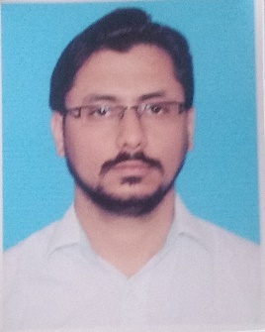

**MUHAMMAD ESSA**

**House No R-198 Memon Nagar 15A/2 Gulzar-e-Hijri**

**Scheme 33 Karachi Pakistan.**

**Cell # +92322-2404881**

**Email:** [**essaarif97@gmail.com**](mailto:essaarif97@gmail.com)

CAREER OBJECTIVE:

**To achieve high carrier growth through a continuous learning process**

**And keep myself dynamic, visionary and competitive with the changing**

**Scenario of the world.**

ACADEMIC QUALIFICATION:

* Matriculation (Science) from Board of Secondary Education Karachi (2006).
* Intermediate (Commerce) from Board of Intermediate Education Karachi (2008).
* Bachelor of Commerce From University of Karachi (2014).

DIPLOMA COURCES:

* Diploma in Systems Management (DISM) from

APTECH.

* Diploma in Supply Chain Management from CILT Pakistan.

CERTIFICATE COURSES:

* English Language Level (2b) Passed With 70% Marks From Inlingua.
* Inbound Call Center training from APEX LINE.
* Certified from silver wings aviation.(C.A.A).

PROFESSIONAL EXPERIENCE:

* 2 years’ experience as an accountant and Cashier in Glamour Fashion.
* 1 year Store Keeper in Al-Tawakkal Fashion.
* 2 Years’ experience in Customer Service Relationship in ARG international. Pharmaceutical company.
* 1 Year working Experience as a Front Desk Admin.
* 1 year Data Entry Operator in Digital Solutions.
* 6 Months experience as an Admin In-charge in Aamir Public School.
* 6 months experience in Warehouse assistant and inventory checker in FMCG Company.
* Currently Working as a Real Estate Adviser.

SKILLS:

* Analytical thinking, Planning
* Strong verbal and personal communication skills.
* Accuracy and attention to details.
* Organization and prioritization.
* Problem analysis, use of judgment and ability to solve problems efficiently.

PERSONAL DATA:

* Father’s Name **MUHAMMAD ARIF**
* Date of Birth 05-05-1988
* Religion Islam
* Nationality Pakistani
* C.N.I.C. # 42101-0889199-9
* Marital Status Married

HOBBIES:

* Computing
* Swimming
* Puzzles
* Socializing with Friends
* Squash

REFERENCES:

* Available if required.